|  |
| --- |
|  |
| Assignment 4 |
| Network Security (UCS727) |

|  |
| --- |
|  |

*Name:*  Sachleen Singh Chani

*Roll No.:* 101506143

*Date:* May 2021

## Q1. Write a program to implement the RSA public-key encryption.

### Answer:

**Code –**

#RSA encryption

#extended Euclidean algorithm

**def** egcd**(**a**,**b**):**

**if(**a**<**b**):**

a**,** b **=** b**,** a

**if(**b**==**0**):**

**return** a**,**0**,**1

g**,**t1**,**s1 **=** egcd**(**b**,** a**%**b**)**

t **=** s1 **-** a**//**b **\*** t1

s **=** t1

**return** g**,**t**,**s

#encryption fucntion

**def** enc**(**plain**,**public**):**

**print(**"\n---Starting encryption---"**)**

e**,**n **=** public

cipher **=** plain**\*\***e **%** n

**print(**"\n---Ending encryption---"**)**

**return** cipher

**def** denc**(**cipher**,**private**):**

**print(**"\n---started deciphering---"**)**

d**,**n **=** private

decipher **=** cipher**\*\***d **%** n

**print(**"\n---ended deciphering---"**)**

**return** decipher

#key generation

p **=** **int(input(**"Enter prime p:"**))**

q **=** **int(input(**"Enter prime q:"**))**

**print(**"\nChoosen primes: \np=" **+** **str(**p**)** **+** ", q=" **+** **str(**q**)** **+** "\n"**)**

n **=** p **\*** q

**print(**"n = p * q = " **+** **str(**n**)** **+** "\n"**)**

phi **=** **(**p**-**1**)** **\*** **(**q**-**1**)**

**print(**"Euler's Phi Function, phi(n)=" **+** **str(**phi**)** **+** "\n"**)**

**print(**"Choose \'e\' from the set {1,2,...,%d}:" **%(**phi**-**1**))**

e **=** **int(input())**

g**,**d**,**s **=** egcd**(**e**,** phi**)**

#to make sure e is a coprime number

**while(**g**!=**1**):**

e**=int(input(**"'e' should be coprime to phi! e="**))**

g**,**d**,**s **=** egcd**(**e**,**phi**)**

#to make the inverse as a positive integer

**while(**d**<**0**):**

d **+=** phi

#public and private keys

public **=** **(**e**,**n**)**

private **=** **(**d**,**n**)**

**print(**"\nYour Public key, KU = {"**,**e**,**","**,**n**,**"}"**)**

**print(**"Your Private key, KR {"**,**d**,**","**,**n**,**"}"**)**

#user input plain text

**print(**"\nEnter message to encrypt:"**)**

plain **=** **int(input())**

#calling cipher function

cipher **=** enc**(**plain**,**public**)**

**print(**"The cipher text is:"**)**

**print(**cipher**)**

#calling decipher function

decipher **=** denc**(**cipher**,**private**)**

**print(**"The deciphered text is:"**)**

**print(**decipher**)**

**Result –**

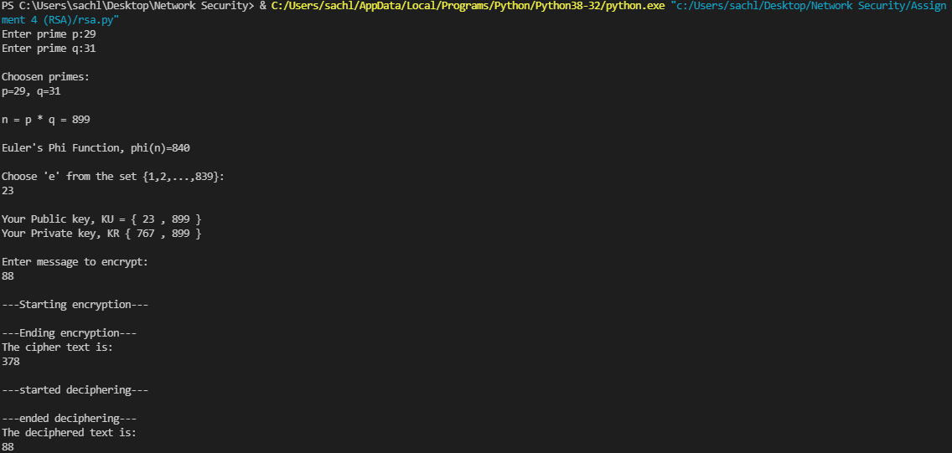

Figure Result for RSA encryption